Replace **<your-name>** with your **name** throughout the Lab.

1. SSH to the **haproxyVM on Azure or any of the master NODE** of the 3 AWS Clusters

|  |
| --- |
| $ sudo su  # vim python_app<your-name>.yaml |

2. **Paste the below script in the dotnet_app.yaml**

Update the image: **lovescloud/python-docker:latest** and replace <yourname> with your namein the below script with your dockerhub image name that you uploaded to docker hub in docker lab Pushing images to docker Hub for python.

|  |
| --- |
| apiVersion: apps/v1  kind: Deployment  metadata:  name: pythonapp-<your-name>  spec:  selector:  matchLabels:  run: pythonapp-<your-name>  replicas: 2  template:  metadata:  labels:  run: pythonapp-<your-name>  spec:  containers:  - name: pythonapp-<your-name>  image: lovescloud/python-docker:latest  ports:  - name: port4000  containerPort: 4000  ---  apiVersion: v1  kind: Service  metadata:  name: pythonapp-<your-name>  labels:  run: pythonapp-<your-name>  spec:  type: NodePort  ports:  - name: port4000  port: 4000  protocol: TCP  selector:  run: pythonapp-<your-name> |

**Save and exit by pressing the ESC key and type wq to save and quit by pressing enter**

3. Run the below commands to deloy the .NET application on your Kubernetes Cluster

|  |
| --- |
| # kubectl apply -f python_app.yaml |

**Example**

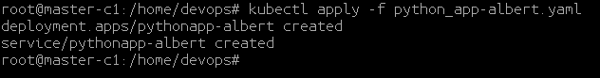

4. Check the NODE where your app has been deployed.

|  |
| --- |
| # kubectl get po -o wide |



5. Check the NODEPORT of the application

|  |
| --- |
| # kubectl get svc |

**Example**

**I**n this example the dotnet application has been exposed on port 30480 as shown in the below.

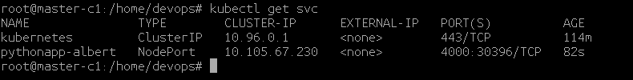

In this example the app has been deployed to the NODE **worker-1.**Login to the Azure/AWS portal and check the public IP of the NODE ( ex worker-1) access the python application web page from the NODE Public IP address and Node Port on which it is exposed at.

http://<NODE-PUBLIC-IP>:NODEPORT

Example.

[**http://3.80.5.138:30396/**](http://3.80.5.138:30396/)

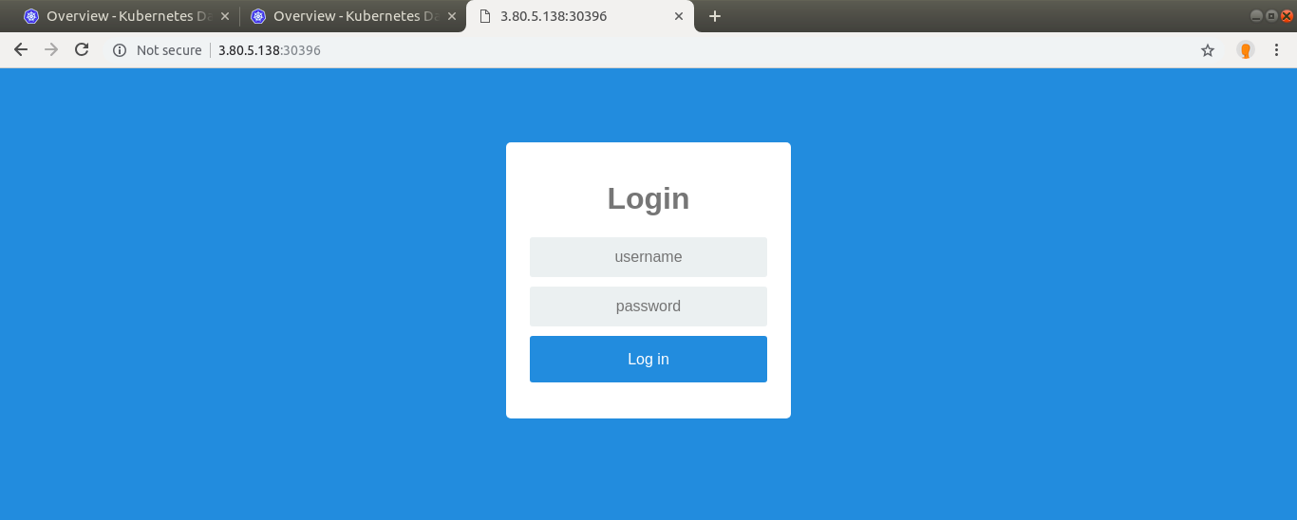

Login with the below credentials.

Username - admin

Password - password

